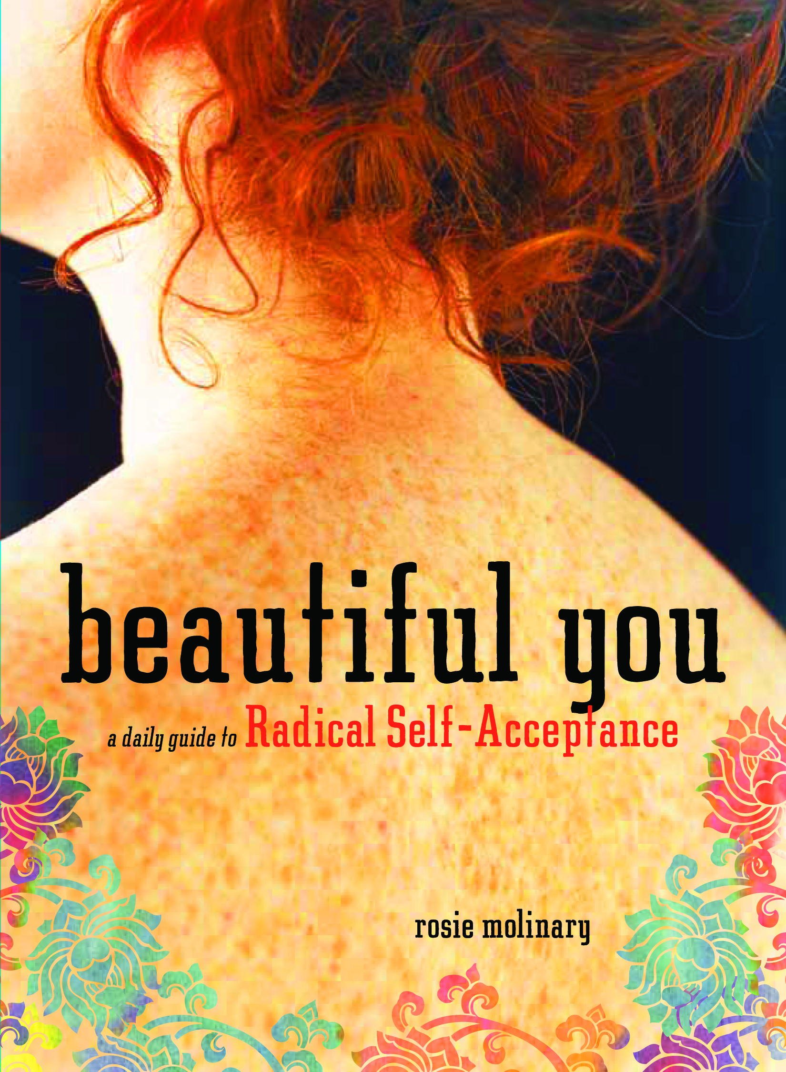

beautiful you. the workshop is a one-day self-awareness and empowerment retreat based on Beautiful You: A Daily Guide to Radical Self-Acceptance. Led by Rosie Molinary, participants will use writing exercises from selected journal prompts, guided discussion in small groups, quiet reflection, gentle movement like stretching and meditative walking, and art to create an action plan for how to care for, champion, and treat their whole selves well.

With a focus on authentic living, the core activities of the day give participants practical and inspirational tools (like journaling and creating vision boards) to fully live lives of their own choosing. Participants will also be introduced to five guiding principles that they can use in guiding their focus and leading their attention away from their physical self. In addition to individual, small group, and large group exercises, participants will enjoy a tranquil setting at the Starrette Farm, a beautiful private homestead spanning 50 acres of rolling woodland and walking trails just 5 minutes off the I-40 and I-77 intersection in Statesville, North Carolina. Morning goodies, lunch, and afternoon snacks will be provided by Nikki Moore, the owner of Food Love and a personal chef.

beautiful you. the workshop is a practical and inspirational day that provides women of all ages support and motivation in a safe, non-judgmental, inspirational environment for championing their own emotional and physical well-being in order to move forward in discovering and living the lives they were meant to live. Space is limited to no more than 20 participants in order to ensure a quality experience for every participant.

November 6, 2010
9 am until 5:30 pm
Statesville, North Carolina

Early bird registration is $100.00 (includes lunch and snacks).
Registration goes up to $125 from September 1 to October 1
and to $150 after October 1.

To register, please complete an order form and mail it along with your check to Rosie Molinary, PO Box 695, Davidson, NC 28036. Checks will not be deposited until after Oct. 1. A month prior to the retreat, you will receive a letter via email with updated information on the retreat and directions to the farm.

Please bring a journal for reflection and a favorite pen. Feel free to bring a copy of Beautiful You: A Daily Guide to Radical Self-Acceptance. If you want to purchase a copy of Beautiful You to pick-up at the retreat, please add $15 to your registration check. Checks should be made payable to Rosie Molinary.

Bio: Rosie Molinary has been leading workshops and retreats for over ten years. An author, speaker, and teacher with a focus on authentic living, she specializes in encouraging individuals to explore, integrate, and solidify their voices in order to empower them with their own truth, confidence, hope, passion and action. Rosie's second book, Beautiful You: A Daily Guide to Radical Self Acceptance, will be published in October 2010 by Seal Press. Hijas Americanas, her book on Latina body image in America, was published by Seal Press in June 2007. In addition to writing, she teaches a course on body image at the University of North Carolina at Charlotte and speaks on body image, diversity, self-awareness, social justice and writing around the country.

Learn more at www.rosiemolinary.com and http://hijasamericanas.wordpress.com.
Facebook: Rosie Molinary
Twitter: @rosiemolinary

beautiful you. the workshop
November 6, 2010
9 am until 5:30 pm
Statesville, North Carolina
registration

Name
Mailing Address
City/State/Zip
Email
Phone (Home) |  |  |  | Phone  (Cell or Work)

What motivated you to sign up for beautiful you. the workshop?

Do you have any food allergies or sensitivities?

How did you hear about beautiful you. the workshop?

Is there anything else you would like for me to know at this time?

This registration form and a check made payable to Rosie Molinary should be mailed to PO Box 695, Davidson, NC 28036. If you would like to pick up a copy of Beautiful You: A Daily Guide to Radical Self – Acceptance at the retreat, please add $15 to your registration fee.

