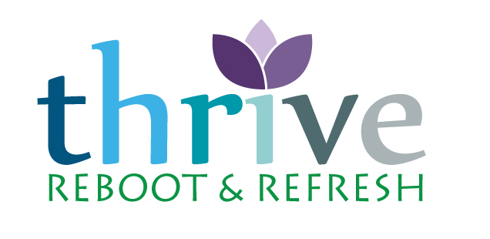
Self-Care Resources

Books

Atomic Habits: An Easy & Proven Way to Build Good Habits & Break Bad Ones by James Clear

Burnout: The Secret to Unlocking the Stress Cycle by Emily Nagoski and Amelia Nagoski

Do Less: A Revolutionary Approach to Time and Energy Management for Busy Moms by Kate Northrup
The Miracle Morning: The Not-So-Obvious Secret Guaranteed to Transform Your Life Before 8AM by Hal Elrod

Slow: Simple Living for a Frantic World by Brooke McAlary

Soulful Simplicity: How Living with Less Can Lead to So Much More
by Courtney Carver

Present Over Perfect: Leaving Behind Frantic for a Simpler, More Soulful Way of Living by Shauna Niequist

Podcasts
100% Guilt-Free Self-Care
Body Kindness
CTZN
Edit Your Life
The Happiness Lab
Love, Curvy Yoga
Needy (Mara Glatzel)
Polly Campbell, Simply Said
Self Care Sundays (Aditi Juneja)
Selfie

Meditation, Self-Care and Therapy Apps
Calm
Fabulous
Headspace
Talkspace

Virtual Courses
The Science of Wellbeing (offered for free on Coursera)

