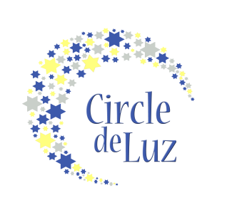
Letter of Commitment- Class of 2024

Name
Mailing Address
City/State/Zip
Email
Phone (H) |  |  |  |  | Phone (C/W)

Involvement

As a Mija donor, you can choose your level of financial involvement. While you must pledge to give a minimum of $100 a year for six years, totaling $600, you can choose to pledge a larger annual sum below. Please indicate your desired giving level below with your initials. Your giving level will not be made public.

____ $100 a year, for a total of $600 over six years
_____ $125 a year, for a total of $750 over six years
_____ $150 a year, for a total of $900 over six years
_____ $200 a year, for a total of $1200 over six years
_____ $250 a year, for a total of $1500 over six years
_____ $500 a year, for a total of $3000 over six years
_____ ______ a year, for a total of _______ over six years

Yes, I want to radically empower and inspire young Latinas to pursue further education upon graduation from high school; therefore, I pledge to give $________a year for six years, for a total commitment of $_________ to the Circle de Luz scholarship program.

Our strength as an organization is rooted in our vibrant collective of volunteers. There are no expectations of involvement beyond the annual financial contribution, however, there are opportunities to share your talents with the young women we serve. Please indicate if you have interests below:

A. ______ I would be interested in serving a 3 year term as a board member which would include attending monthly meetings, in addition to, several programs annually.

B. ______ I would be interested in serving for 6 years as a Class Captain for a future class and supporting the girls through their journey from 7th-12th grade by attending monthly programs.

C. ______ I would be interested in serving as a College 101 Mentor to help the upperclassmen through their college journey. Up to a three year commitment.

D. ______ I would be interested in offering a workshop for the girls or their families on the following topic (ex: yoga, cooking, financial literacy, leadership skills, writing)
______________________________________________________________________

E. ______ I would be willing to serve as a periodic chaperone for events

F. ______ I would be interested in hosting a fundraising or friendraising event on behalf of Circle de Luz.

G. ______ I have access to civic or professional groups and would be interested in facilitating a speaking engagement for Circle de Luz.

H. ______ I would be interested in sharing my career experience on a panel or during a program. My profession is _____________________________________

General Questions

1. Can we identify you as a Circle de Luz donor in our materials such as newsletters and annual reports?
___ Yes ___ No

2. How did you find out about our program?
_______________________________________________________________________

Signature__________________________ Date_____________

You do not need to make a financial contribution until September 2018. You will be sent an email at the time your first commitment is due. For each annual financial contribution, 10% will go towards the administrative costs of the scholarship fund and the remainder of the commitment will go directly to the scholarship fund for the Class of 2024. For more information about Circle de Luz, visit www.circledeluz.org.

When completed, please mail or scan and email to:
Circle de Luz, P.O. Box 2, Davidson, NC 28036
karinavogel@circledeluz.org

Financial information about this organization and a copy of its license are available from the Charitable Solicitation Licensing Section at 888-830-4989.
This license is not an endorsement by the State.

