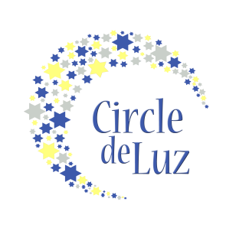
My Letter of Commitment- Class of 2021
Name
Mailing Address
City/State/Zip
Email
Phone (H) |  |  |  |  | Phone (C/W)

Involvement
As a Mija donor, you can choose your level of financial involvement. While you must pledge to give a minimum of $100 a year for six years, totaling $600, you can choose to pledge a larger annual sum below. Please indicate your desired giving level below with your initials. Your giving level will not be made public.
_____ $100 a year, for a total of $600 over six years
_____ $125 a year, for a total of $750 over six years
_____ $150 a year, for a total of $900 over six years
_____ $200 a year, for a total of $1200 over six years
_____ $250 a year, for a total of $1500 over six years
_____ $500 a year, for a total of $3000 over six years
_____ ______ a year, for a total of _______ over six years

Yes, I want to radically empower and inspire young Latinas to pursue further education upon graduation from high school; therefore, I pledge to give $_________a year for six years, for a total commitment of $_________ to the Circle de Luz scholarship program.

__________________________________Signature ______________Date

Can we identify you as a Circle de Luz donor in our materials such as newsletters and annual reports? ___ Yes ___ No

How did you find out about our program?

______________________________________________________________________

You do not need to make a financial contribution until September 2015. You will be sent an email at the time your first commitment is due. For each annual financial contribution, 10% will go towards the administrative costs of the scholarship fund and the remainder of the commitment will go directly to the scholarship fund for the Class of 2021. For more information about Circle de Luz, visit www.circledeluz.org.

When completed, please mail or scan and email to:
Circle de Luz, P.O. Box 2, Davidson, NC 28036
circledeluz@gmail.com

Financial information about this organization and a copy of its license are available from the Charitable Solicitation Licensing Section at 888-830-4989. This license is not an endorsement by the State.

