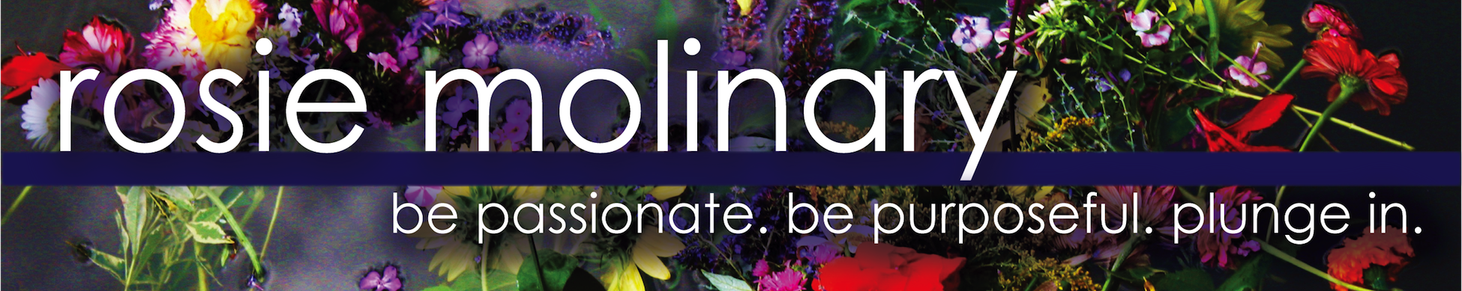

High Schools and Colleges

Amherst College
Berry College
Blythewood High School
Brown University
Community School of Davidson
Davidson College
Davidson Day School
Dwight D. Eisenhower High School
Gaston College
Guilford College
Fordham University
John V. Lindsay Wildcat Academy Charter School
Loyola University
Middlebury College
Mount Holyoke College
New York University
North Carolina State University
Ridge View High School
Richland Northeast High School
Rutgers University
Spring Valley High School
State University of New York- Fredonia
Tufts University
University of California- Riverside
University of Georgia
University of Maryland
University of Massachusetts- Amherst
University of North Carolina Medical School- Charlotte Campus
University of North Carolina-Charlotte
University of North Carolina- Greensboro
University of North Carolina-Wilmington
University of Saint Joseph
University of Texas- El Paso
Vanderbilt University
Western Illinois University
Winston Salem State University
Winthrop University

Businesses, Civic Groups, and Conferences

AHAA: The Voice of Hispanic Advertising Conference
Alpha Delta Kappa Southeast Regional Conference
Association of International Women, Indianapolis
Blue Cross and Blue Shield Foundation Non-profit Leadership Conference
Boys and Girls Club of America National Conference
Carolinas Healthcare System Center for Faculty Excellence
Carolinas HealthCare System Department of Family Medicine
CHUBB Insurance
Crossroads Charlotte
Davidson College Women’s Leadership Conference
Developmental Disabilities Resources, Charlotte
Environmental Protection Agency (North Carolina)
Immigration Custom Enforcement, El Paso, Texas
GE Capital Women’s Network, Charlotte, North Carolina
Junior League of Charlotte
La Plaza, Indianapolis, Indiana
Latina American Women’s Association, Charlotte, North Carolina
North Carolina Society of Hispanic Professionals Hispanic Education Summit
Right in the Middle Mother-Daughter Conference, Charlotte, North Carolina
Women’s Inter-Cultural Exchange Conference

