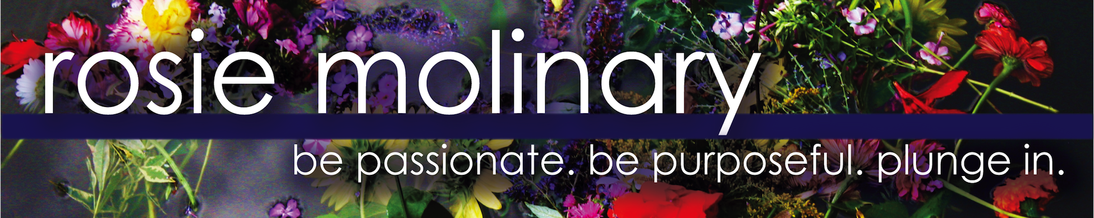
Bio
Rosie Molinary, M.F.A., is an author, educator, and activist who empowers women of all ages to embrace their authentic selves so they can live their passion and purpose and give their gifts to the world.

In her first book, Hijas Americanas: Beauty, Body Image, and Growing Up Latina (Seal Press, 2007), Molinary sheds new light on what it means to be a Latina growing up in the United States. Based on interviews and surveys Molinary conducted and collected from more than 500 Latinas of Mexican, Caribbean, Central American, and South American descent, Molinary provides a powerful understanding of the inner conflicts and triumphs of first, second, and third generation Latinas as they come of age. The book, and the captivating stories of the women featured, gives an empowering voice to the struggles and successes of all women across racial, sexual, and cultural identities.

In Beautiful You: A Daily Guide to Radical Self-Acceptance (Seal Press, 2010), Molinary provides women with 365 exercises to build confidence, encourage self-awareness, and get reacquainted with themselves. Part personal essay, part action and empowerment guide, Beautiful You is a practical and inspirational tool for realizing a healthy self-image by championing one’s own emotional and physical well-being. With daily entries that inspire readers to find their voice, stop critical conversations, and embrace themselves fully, Beautiful You gives readers the encouragement and instruction they need to change their lives.

Molinary’s writing and books have been featured in a wide variety of magazines and on websites around the world including The Huffington Post, Mamiverse, Voxxi, Woman’s Day, Cosmo Latina, Cosmopolitan South Africa, Chaletaine, Whole Living, Natural Health, Latina, Teen Vogue, Health, Women’s Health, Ms., Lifetimetv.com, Skirt!, PsychCentral, iVillage, Charlotte Observer, Energy Times, Shelter Pop on AOL, Single Woman TV, MamaLatina on About.com, and Indian Country Today.

She is a regularly featured expert on Charlotte Today and has done dozens of radio and television interviews including Tell Me More on NPR, Martha Stewart radio, NBC Charlotte, WBTV CBS- Charlotte, Feminist Magazine, The Satisfied Life, Charlotte Talks, and Girlfriendology. She has also been featured as a Foot Solider of The Week on The Melissa Harris-Perry Show on MSNBC.

In addition to her writing, she teaches body image at the University of North Carolina-Charlotte, facilitates transformative workshops and retreats for girls and women, and speaks on body image, self-acceptance, Latina issues, media literacy, body and soul-positive parenting, and intentional living around the country at various colleges, schools, and conferences.

A graduate of Davidson College with a degree in African-American Studies and certification as a high school Social Studies teacher, Molinary’s first career was as a teacher, coach, and Director of Student Activities at a high school in Charlotte, North Carolina. Troubled by the lack of voice she witnessed in her high school students, Molinary left teaching to pursue a graduate degree in creative writing, hoping she could use writing as a tool to help individuals live authentically, find their passion and purpose, and give their gifts to the world. A graduate of Goddard College’s Master’s of Fine Arts program, Molinary’s first book, Hijas Americanas: Beauty, Body Image, and Growing Up Latina, was inspired by her graduate manuscript of non-fiction essays and linked poetry entitled Giving Up Beauty.

Rosie helped found HAMMERS, a nonprofit initiative to provide emergency home repair services for low-income families in her area, and is the founding and acting board chair of Circle de Luz, a non-profit that radically empowers young Latinas by supporting their transformation through extensive mentoring, holistic programming and scholarship funds for further education. She lives in North Carolina with her family.

