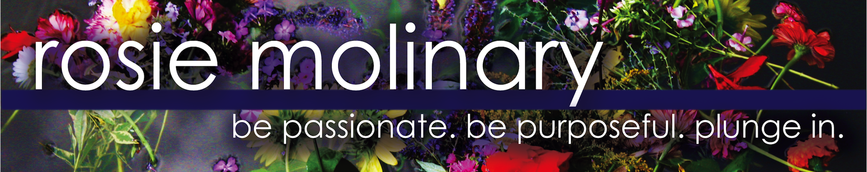

CORPORATE OFFERINGS

The Case for Self-Care
In this 2-hour workshop, I make a powerful case for self-care. From exploring why self-care makes a significant difference in one’s ability to thrive and be on purpose to articulating how self-care can be most powerfully sustained by small moments strung together as opposed to just grand moments (a day at the spa!), attendees will understand why self-care matters, especially for care providers, and what it looks like. Finally, participants will write personal wellness plans to use as catalysts and clarifiers in their own self-care. Ultimately, this session will allow participants to forge a deeper self-awareness, practice greater self-acceptance, and examine their self-care in a way that empowers them to be their greatest ally.

On Mission
In this 3-4 hour workshop, I will guide a business team/organization in identifying their join values, crafting their institutional or organizational mission statement, and articulating their guiding beliefs. This power team building opportunity generates profound community input and buy-in while creating an inspiring outcome for the organization. Finally, we will review how to use an organization’s values, mission statement, and guiding beliefs as a blueprint for action.

On Purpose
In this 2-hour workshop, I will introduce participants to the concept of personal mission statements inspired by the importance of powerfully living one’s purpose. Participants will then draft and edit their own mission statements by going through a powerful exercise that I have designed. Finally, we will review how to use one’s mission statement to inspire and guide one’s choices and actions.

The Wholehearted Continuum
In this 1-hour keynote, participants will learn a powerful way to discern their boundaries through The Wholehearted Continuum and will review ways to say no to too many commitments and best practices for managing one’s time.

New Year Personal Summit
In this 90-minute workshop, I will guide participants in a powerful reflection on 2016 before introduce them to a powerful framing tool for 2017: choosing a word for the year. Participants will learn a new paradigm for how to frame their intentions for the New Year – the word of the year, understand why it is more powerful than traditional New Year’s Resolutions, complete exercises that help them choose a word, and then learn how to use the word as guide in 2017.

Manifest
In this 2-hour workshop, I will guide participants in writing manifestos for their organizations. Whether they chose to write their manifestos for their clients, participants, leadership or around the greater issues they are addressing, each organization will draft and edit their own manifestos by going through a powerful exercise I have designed. They will share their manifestos and then learn how to use them in a powerful way within (or outside) their organization.

Spark Your Systems
In this 2-3 hour workshop, I will guide participants in implementing a powerful time management/ personal organization system that will allow them to clearly track their responsibilities and commitments, plan their weeks in a proactive way, and accomplish their priorities in a positive, productive manner.

Rosie Molinary

As a radical self-acceptance champion, Rosie Molinary, MFA, uses profound questions and wholehearted connection to empower people to treat themselves well so they can connect with their talents and passions to authentically and intentionally live their purpose and help heal the world.

The author of Beautiful You: A Daily Guide to Radical Self Acceptance (Seal Press) and Hijas Americanas: Beauty, Body Image, and Growing Up Latina (Seal Press), Rosie teaches at the University of North Carolina at Charlotte, serves as a national Dove Self-Esteem Project educator, offers workshops and retreats, and speaks on self-acceptance, body image, self-care, media literacy, the Latina experience, and intentional living around the country. Rosie also serves as a creative catalyst to companies and brands that wish to provide a synergistic, empowered and soulful experience to their clients and employees as they serve the world through workshop and retreat facilitation and consultation.

