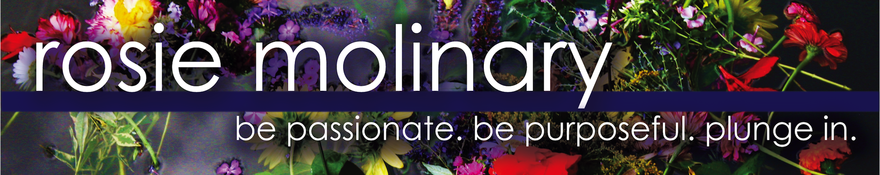

What Inspires My Work

I am not a body image activist.

Well, I am, but not for the reasons you might think.

As a lecturer in Women’s and Gender Studies at the University of North Carolina at Charlotte, I have the great pleasure of teaching a seminar on body image. But with that honor comes the difficult reality of listening to my students’ heartbreaking beliefs and ideas about their bodies and their worth. Several years ago, when we were exploring media literacy and the impact that marketing and media have on us, an idea came to me. Impulsively, I dared my students to go completely natural for a day.
I had no idea how many of my students would take on the challenge, but come the morning of our experiment, all of them walked in without any enhancements- no hair products, extensions, styling tools or aids, make-up, contacts, or perfume. Needless to say, they were breathtaking not just despite their lack of make-up but because they were real and vulnerable. And they started to see it, too.
The Charlotte Observer sent a photographer, and I wrote a piece for the paper about the experience to accompany the photos. To my dismay, some of the commenters on the piece lamented the fact that university resources (tax payer dollars!) were being directed to teach this sort of class. What a waste, some of them said. These kids will have no marketable skills and an inflated sense of self, they continued. Having spent years teaching this course, I cannot disagree more.
I’ve had a varied career, doing work that made me feel on purpose, and this self-acceptance work is some of the most important work I’ve ever done. But it is not important because my students can look in the mirror at the end of the semester and like what they see. Contrary to what some might believe, the accomplishment at the end of the semester isn’t that a smattering of young people get such inflated egos from feeling so much better about themselves that they lose all perspective. The real accomplishment at the end of the semester is that my students leave the class no longer paralyzed about how they feel about themselves, with a sense of empowerment about what they have to offer, and with an invigorated perspective so that they can go out and do work that they feel really matters to them and the world. That we have so much more to offer than our bodies is the most essential self-acceptance lesson I teach.
So I am not just a body image activist. I am a global activist, an instigator, an advocate, a rabble rouser who wants people to realize that we each have a purpose that is uniquely ours. Yes, I think every one of us has not just the right but the responsibility to respect the vessel that carries us through life. Yes, I think that other people’s standards- whether we are talking about our mom or the media- should not factor into our awareness of our worth. Yes, I think that how we see ourselves fundamentally needs to change. But I do not think these things because what we see in the mirror is important. I think these things because too much else is important and we have over-prioritized our reflection.

This world is full of needs. And not one of us is here by accident. We are, each one of us, the living embodiment of a unique solution this world needs. We each have a purpose that is uniquely ours. We each have a solution- or multiple solutions- we are meant to manifest. And our lives are meant to be the realizing, creation of, and expression of those solutions. If we are consumed by our bodies, then we are taking valuable time away from the work we are meant to be doing and the gifts we are meant to be giving to this world, from our purpose. If we are in the mirror, assessing, obsessing, critiquing, despairing, we are not doing the work we are meant to be doing in this broken and aching world that has been waiting for us to step fully into ourselves and our power so we can address the need we are meant to address and bring about the healing we have been called to offer. What are you not doing while looking in the mirror, lamenting your fate? When we get sidetracked, we are taking away from the time and energy we can invest in our purpose and passion.
But how do we get to that place of healthy self-acceptance, of living our passion and purpose? Helping girls and women understand the fundamentals of self-acceptance, gather greater self-awareness, and articulate their passions, strengths, and hopes so they may intentionally galvanize that energy into not just a passionate expression of who they are but a purposeful one is central to the work that I do.
The world is too precious, its needs too real, for any one of us to be hindered by the marketing, the madness, the messages that come at us at warped speed in an attempt to slow us down, distract us, dull us. There is no room for us to play small or scared. But to not play small or scared means we must do the work that allows us to slide into our best selves. Because when we arrive there, what we have is not just self-acceptance. What we have is the ability to pull off one of the many miracles this world needs. It is not cosmic accident that we are here, right now. But it will be a tragedy if we don’t realize it.
The world is waiting for us to change because when we change, it can change. To paraphrase the old adage, we are, each one of us, the ones the world has been waiting for. Our realization of this truth and our ability to embrace it changes everything. We can’t afford for that not to happen.

