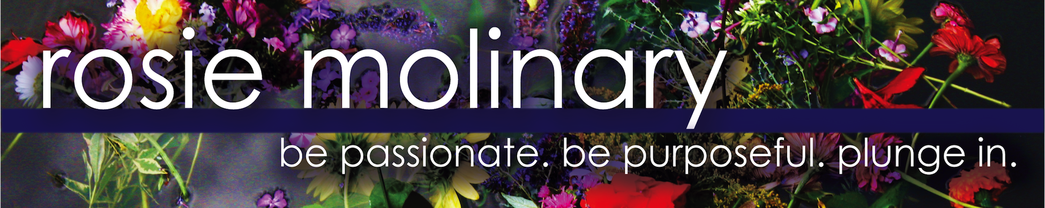
Bio
As a radical self-acceptance champion, Rosie Molinary, MFA, uses profound questions and wholehearted connection to empower people to treat themselves well so they can connect with their talents and passions to authentically and intentionally live their purpose and help heal the world.

The author of Beautiful You: A Daily Guide to Radical Self Acceptance (Seal Press) and Hijas Americanas: Beauty, Body Image, and Growing Up Latina (Seal Press), Rosie teaches at the University of North Carolina at Charlotte, serves as a national Dove Self-Esteem Project educator, offers workshops and retreats, and speaks on self-acceptance, body image, self-care, media literacy, the Latina experience, and intentional living around the country. Rosie also serves as a creative catalyst to companies and brands that wish to provide a synergistic, empowered and soulful experience to their clients and employees as they serve the world through workshop and retreat facilitation and consultation.

A committed activist, Rosie helped found HAMMERS, a non-profit initiative to provide emergency home repair for low income families in her community, and Circle de Luz, a non-profit that radically empowers young Latinas by supporting their transformation through extensive mentoring, holistic programming and scholarship funds for further education.

